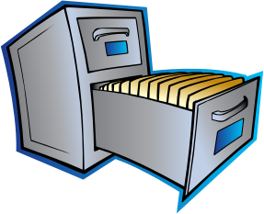**Organizing Documents**

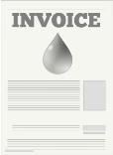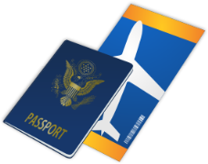

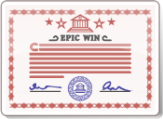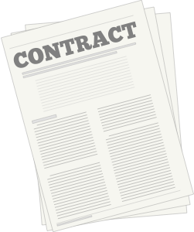

file folder

file cabinet

documents



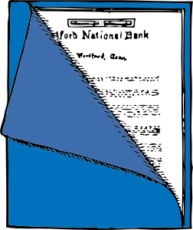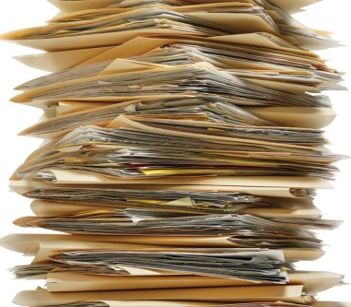

pile of folders

binder

folder

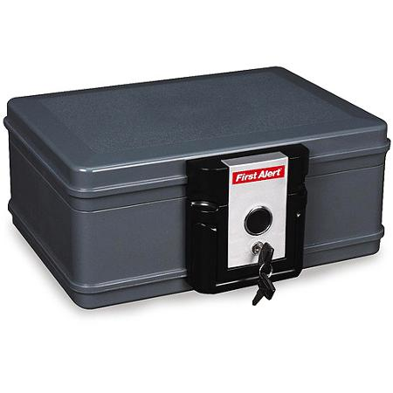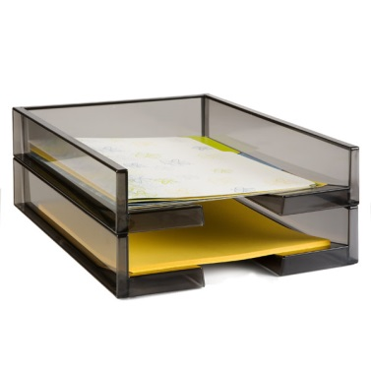

security box

tray

1. How many places do you keep your school papers? Where are they?
2. Why do you need to find school papers?
3. What are three important documents you have at home?
4. Why do you need to find documents?
5. Which papers are easy for you to find? Which ones are difficult to find?

|  |  |  |
| --- | --- | --- |
| **Places for School Papers** | **Advantages** | **Disadvantages** |
| folder |  |  |
| binder |  |  |
| backpack or other bag |  |  |
|  |  |  |

|  |  |  |
| --- | --- | --- |
| **Places for Important Documents** | **Advantages** | **Disadvantages** |
| pile on a table |  |  |
| file cabinet |  |  |
| security box |  |  |
|  |  |  |