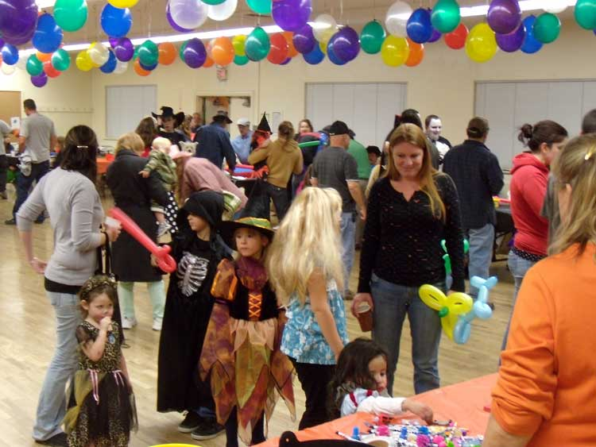
Halloween
Halloween is October 31. It is an old holiday that came to the United States with Irish immigrants. It is a day and night for fun, tricks, and costumes. Children love this holiday and many adults like it, too.

Some people decorate their homes and yards. Typical Halloween symbols are witches, black cats, skeletons, ghosts, and decorated pumpkins, called jack-o’-lanterns. Black is the color of winter and long nights. Orange is the color of the harvest.
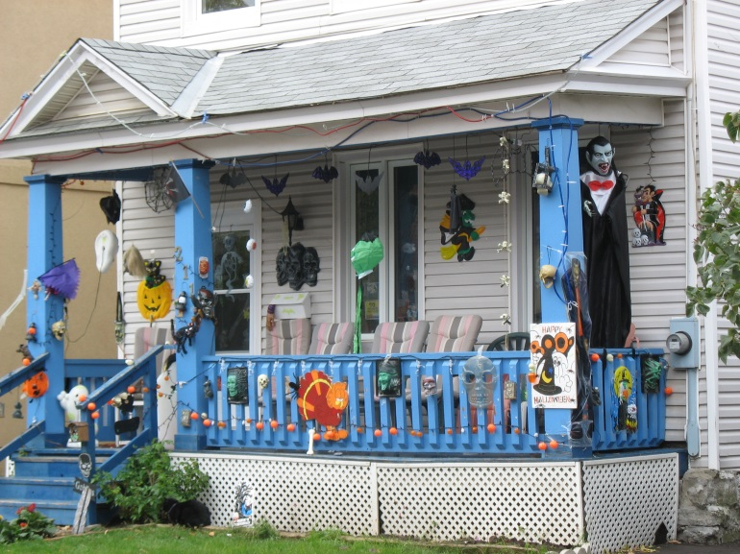

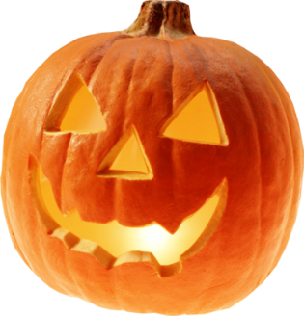

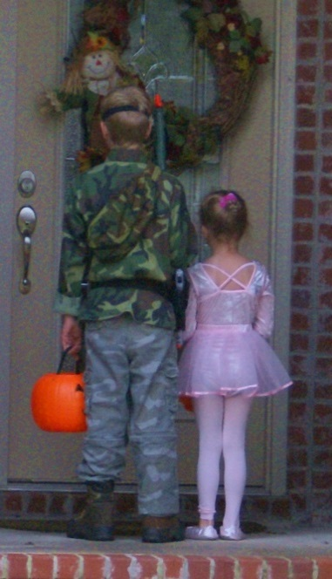

Some schools have Halloween parades and children wear costumes to school. After school, or at night, children go to homes in their neighborhood to go trick-or-treating. They knock on the door. When a person opens the door, the children say, “Trick or treat!” The neighbor gives the children candy or gum, pencils or money.

If you have children, help them stay safe on Halloween. Young children need to go out with an adult and carry a light. Older children can go with a group of friends. If you are driving, be careful! There will be lots of children out in the streets.

- Find the word costume in the second sentence. Look at the first picture in the text. What does costume mean?

- Find the word decorate in second paragraph. Look at the second picture in the text. What does decorate mean?

- The text says that children love Halloween and many adults like it too. What reasons for liking Halloween can you find in the text?

- Look at the text again. What do adults and children do differently for Halloween?

- Why does the author say to stay safe on Halloween?

